**Exercise:**

**How to Create Bots (Robots) using UI path**

**Steps:**

1. Navigate to Ui-path
2. Create the sequence for the scenario required
3. Make the scenario working
4. Click on Publish button in the Ribbon menu bar
5. Successful publish will give you the path of the package
6. Navigate to UIRobot.exe file from the app folder

(Ex: C:\Users\Narendra_v\AppData\Local\UiPath\app-18.3.1)

1. Double click the robot instance will come in tool bar
2. Open UI-path robot and click on refresh option
3. Loaded package will be displayed
4. Download the package and run the package (instance will run as individual robot, without having opened UI-studio, Sequence can be invoked)
5. Please refer below screen shot for your reference
6. Open the sequence

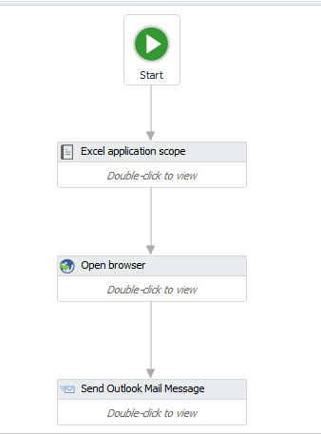

1. Navigate to Design Tab and click on publish button (published package will be seen in below path)

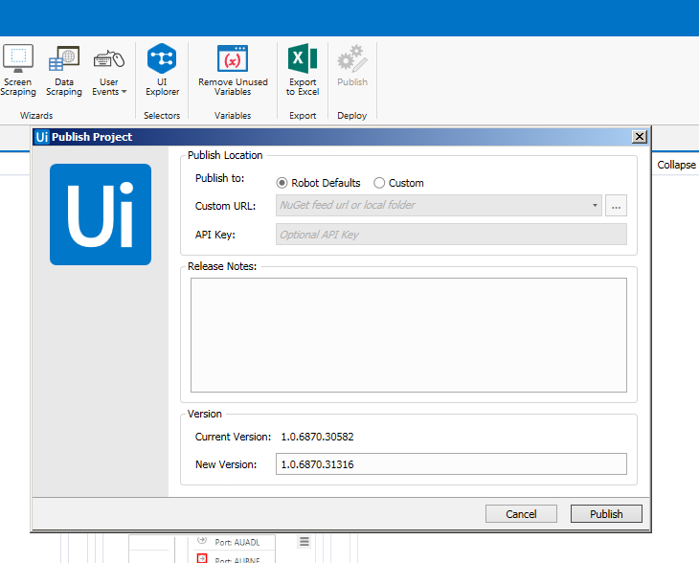

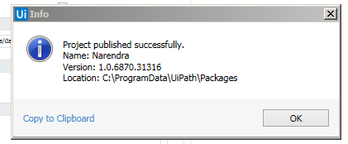

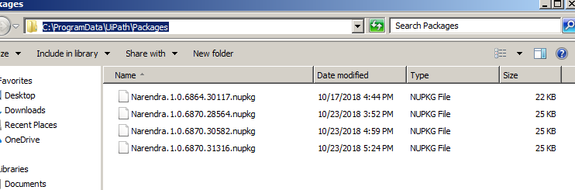

1. Navigate to Ui robot.exe, click on refresh and update the NuGet package, then start running the bots without using Ui Studio

